Ryan Williams

10/31/10

Individual Project 3

Dr. Ahmad Zargari

IET 419

1. As you can see in the Pareto diagram below, refusal was the largest reason for returned shipments. This category is made up 59% (195,000).

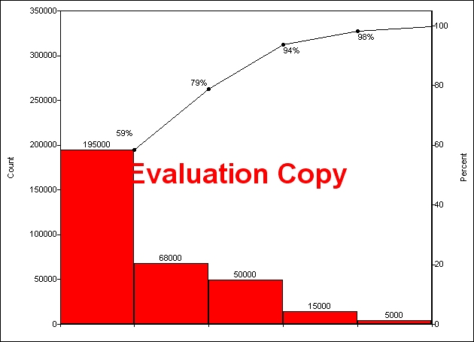

5. The data even takes on the traditional bell shape curve. There were no means of making a tally sheet. The chart indicates that 36 samples fall between 6.00 and 6.01 and that the average weight of the bottles is 5.995.



8. There does not seem to be any points out of control.



13. The central line is 6.064, and the control limits are 6.929 and 0.

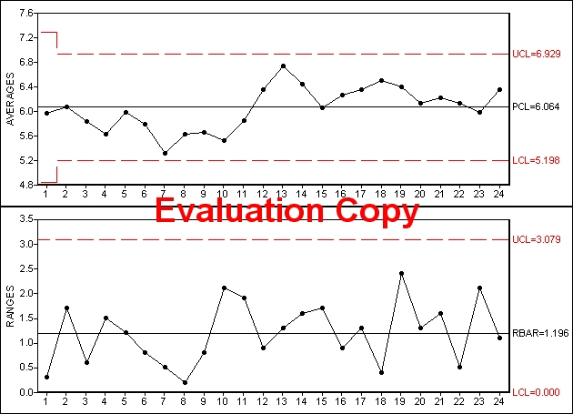

14. The chart indicates the decrease of viscosity liquid in a shift.

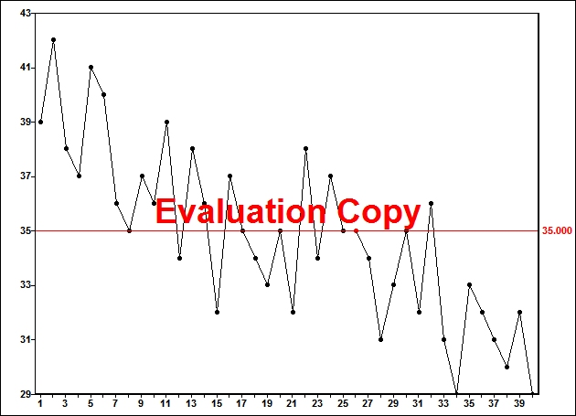

15. Subgroup 5 has one out of control point.

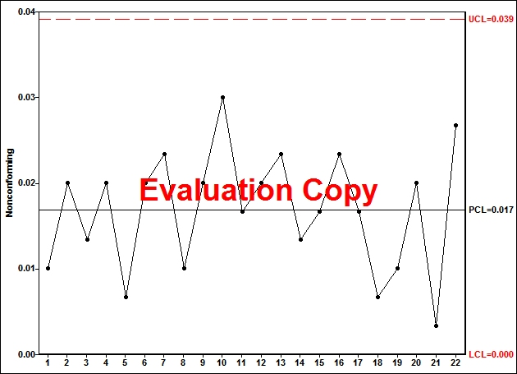

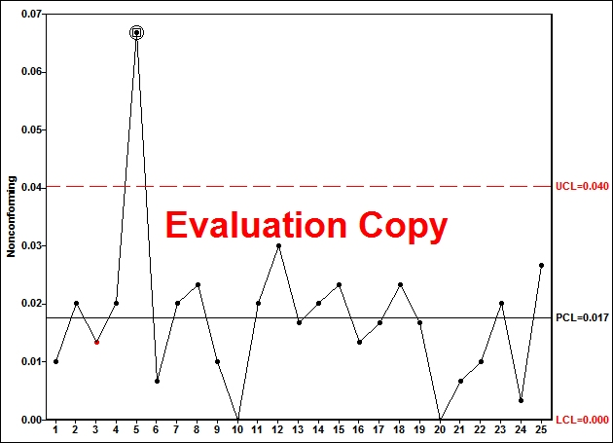

16. Subgroup 6 has one out of control point.

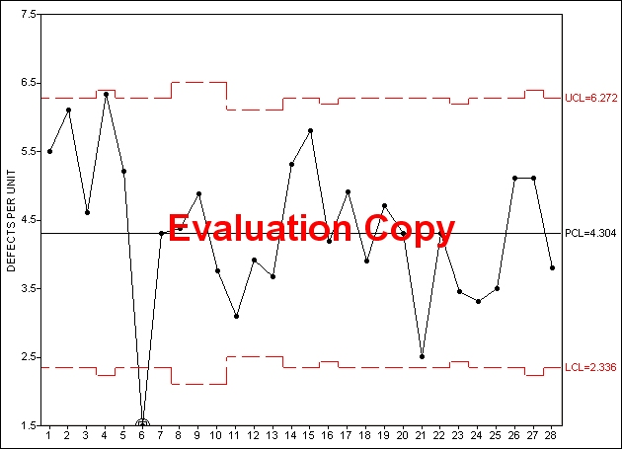

19. There seems to be a relationship between temperature and the foam %.

