IET 430
Group D Final Project
Dec 9th 2010
Darin English
Brian Salyer
Ryan Williams

Abstract
During the course of this project, this team worked hard to develop a problem situation where a facility was needed to be designed to fill a need. We designed and example product that was to be manufactured, assembled, and shipped out from a plant and then researched what type of factory we would need to design to accommodate the production of our example product, which happened to be a simple c-clamp assembly. Using the techniques and guides found in the Facility Planning and Design Text Book by Garcia-Diaz and Smith, we developed this report. Found within this report is the 6 phases to facility design as outlined. In each phase, tables were created, data was figured, designs were planned, and decisions are made. Through doing this report, we all learned many useful theories and professional ideas about what goes into the planning of a facility. This was an extremely helpful project to work on and each member of this team is better suited to a profession in management and facility design thanks to our project.

Table of Contents

Abstract 2
Table of Contents 3
Phase 1: Product Design 5
Introduction 5
Sections 5
Assembly Drawing 6
Bill of materials 7
Assembly flowchart 7
Summary 8
Conclusion 8
Phase II: Process Design 9
Manufacturing route sheets 9
Machine requirements table and costs 11
Material requirements table and costs 11
Machine drawings 12
Phase III: Layout Planning and Material Handeling 15
Layout Planning Sheets 15
MATERIAL HANDLING REQUIREMENTS AND COSTS TABLE 17
Phase IV: Personnel Requirements 18
Personnel requirements and costs 18
Corporate structure 19
Unit cost 20
Phase V: Office Layout 21
Activity relationship chart 21
Alternative office layouts 22
Selected office layout 24
Phase VI: Factory Layout 25
Introduction 25
Summary of Enhancements 25
Computerized Approach 25
Proposed Layout 26
Plant Layout Summary Sheet 28
Summary, Conclusions, and Recommendations 28

Phase 1: Product Design

Introduction
For our project, we chose to design a C-clamp. This was chosen because it seems like a product that could easily be designed and manufactured inside of one facility. We did some research into companies that produce similar mechanical devices to get an idea of how large and detailed of a device could be made. The facility will need to be laid out in a manner that on one end, the individual parts are be casted and then sent down conveyors to be cooled and finally to assembly line workers who will piece the device together using their work area and tools. The complete product should be then packaged in bulk and sent to redistributors on freight liners. Several cast molding machines will be needed that can do cast iron and carbon steel. Several conveyors will be needed, a multitude of workers, product packaging area, and truck loading bays. An office for supervisors, records, and employee clock in/out will be needed and the areas in the facility need to be positioned in a way that the entire process is as simple and effortless as possible to increase the ppm of each line and decrease to cost of production of each part. Our objectives were to take a pre-existing device and provide our own take of it. Providing any changes that we felt should be made in order to improve the product.

Sections
We have generated drawing of the individual parts that will make up our mechanical device. There are four parts, which are the C-body, threaded screw with ball head, a sliding handle rod, and a swivel head. Each part has a certain function in the device. The C-body is the main component of the clamp, serving as the main body of the device. It has been designed to custom specification that we have chosen. The specifications are 8” length, 6” tall, and ¼” to 1” thick. It will be casted using iron that will be shipped into the factory. The other three parts will be casted out of carbon steel that will be shipped into the factory as well. The treaded screw is used to control how far and fast the clamp function of the device goes. As it is rotated, the treading is used as a guide for the advancement of the head. It is inserted into the hold located on the c-body. The screw is 7” long and has a 0.4” radius. The next part is the sliding handle rod which is used to turn the treaded screw. The rod is inserted in the hole located on the head of the screw. Its specifications are 6” long, with a 0.2” radius, and rounded ends for better gripping. The last part is the swivel head which is located on the opposite end of the treaded screw once it has been inserted into the c-body. The head is used to securely hold an object that has been inserted into the clamp. It is 1” long, and has a 0.3” to 0.6” radius. Once all of these parts have been put together, they will make a functioning c-clamp.

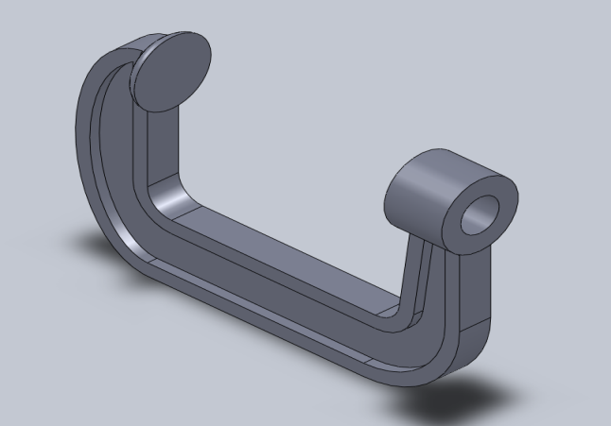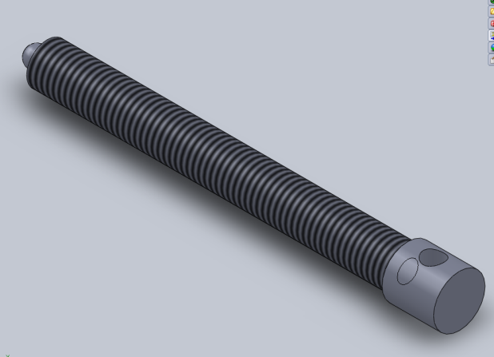

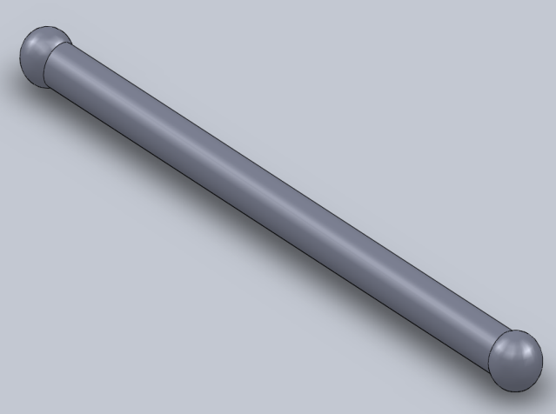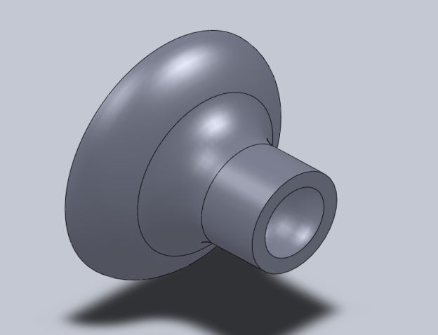

Assembly Drawing
This is an assembly drawing of the c-clamp that our factory will manufacture. It shows how all the parts should look once they are assembled together. All parts will be made in house and assembled in house as well.
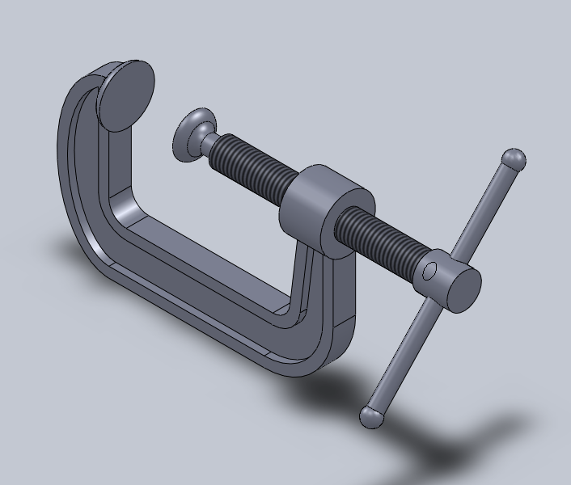

Bill of materials
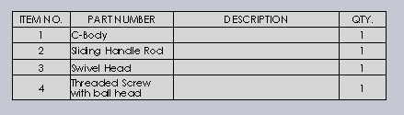

Assembly flowchart
This picture shows an exploded view of the clamp. This view allows for the process for assembling it to be shown.
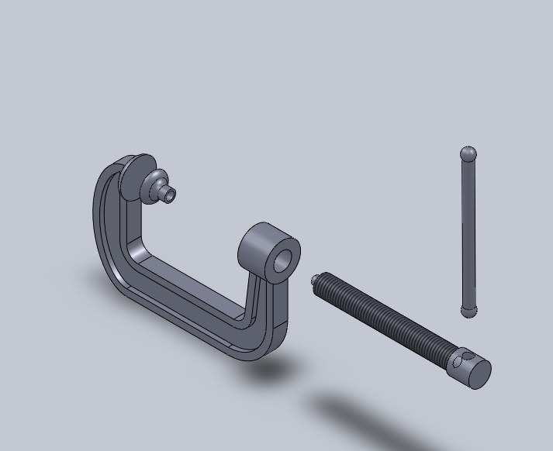

Summary

The body is cast molded with cast iron purchased from a cast iron supplier. The other three parts are to cast molded from carbon steel purchased from a carbon steel supplier. The facility will need to be laid out in a manner that on one end, the individual parts are be casted and then sent down conveyors to be cooled and finally to assembly line workers who will piece the device together using their work area and tools. The complete product should be then packaged in bulk and sent to redistributors on freight liners. Several cast molding machines will be needed that can do cast iron and carbon steel. Several conveyors will be needed, a multitude of workers, product packaging area, and truck loading bays. An office for supervisors, records, and employee clock in/out will be needed and the areas in the facility need to be positioned in a way that the entire process is as simple and effortless as possible to increase the ppm of each line and decrease to cost of production of each part.

Conclusion

Our C-Clamp will be sturdy, reliable, and thoroughly tested for quality. Since the clamp will be made of cast iron and carbon steel, we are expectant of our product to have a long life span. Our machines will be operated by human workers, but our options are open to some computerized programs. We will train all of our workers thoroughly to OHSAA plus our own standards.

Phase II: Process Design

Manufacturing route sheets
ROUTE SHEET
PART NAME | C-Body | DATE | 10/16/2010 | DRAWING NUMBER |  | 1
PART NUMBER | 1 | PREPARED BY | Brian Salyer | LOT SIZE |  | 100
MATERIAL | Cast Iron
OPERATION  NUMBER | OPERATION  DESCRIPTION | MACHINE NAME | JIGS, TOOLS,  FIXTURES, ETC. | STD. TIME  (sec) | MACHINE  CAPACITY  PER HOUR | MATERIAL  REQUIRED  QUANTITY
1 | Inject Iron  into Cast | Cast Iron  Injection Mold | Wrench and  Injection Keys | 10 | 360 | 2 lbs
2 | Let Cast Cool | Cool Down Line | Hook and Bar | 600 | 400
3 | Remove Part  from Cast | Crowbar and  Hammer | Crowbar and  Hammer | 30 | 120
4 | Grind off  Nubs | Grinder | Grinder | 45 | 80

ROUTE SHEET
PART NAME | S Hndl Rod | DATE | 10/16/2010 | DRAWING NUMBER |  | 2
PART NUMBER | 2 | PREPARED BY | Brian Salyer | LOT SIZE |  | 100
MATERIAL | Cast C Steel
OPERATION  NUMBER | OPERATION  DESCRIPTION | MACHINE NAME | JIGS, TOOLS,  FIXTURES, ETC. | STD. TIME  (sec) | MACHINE  CAPACITY  PER HOUR | MATERIAL  REQUIRED  QUANTITY
1 | Inject C Steel  into Cast | Cast C Steel  Injection Mold | Wrench and  Injection Keys | 10 | 360 | 0.3 lbs
2 | Let Cast Cool | Cool Down Line | Hook and Bar | 300 | 400
3 | Remove Part  from Cast | Crowbar and  Hammer | Crowbar and  Hammer | 20 | 180
4 | Grind off  Nubs | Grinder | Grinder | 30 | 120

ROUTE SHEET
PART NAME | Swivel Head |  | DATE |  | 10/16/2010 |  | DRAWING NUMBER |  |  |  | 3
PART NUMBER | 3 |  | PREPARED BY |  | Brian Salyer |  | LOT SIZE |  |  |  | 100
MATERIAL | Cast C Steel
OPERATION  NUMBER | OPERATION  DESCRIPTION |  | MACHINE NAME |  | JIGS, TOOLS,  FIXTURES, ETC. |  | STD. TIME  (sec) |  | MACHINE  CAPACITY  PER HOUR |  | MATERIAL  REQUIRED  QUANTITY
1 | Inject C Steel  into Cast |  | Cast C Steel  Injection Mold |  | Wrench and  Injection Keys |  | 7 |  | 514 |  | 0.1 lbs
2 | Let Cast Cool |  | Cool Down Line |  | Hook and Bar |  | 300 |  | 400
3 | Remove Part  from Cast |  | Crowbar and  Hammer |  | Crowbar and  Hammer |  | 10 |  | 360
4 | Grind off  Nubs |  | Grinder |  | Grinder |  | 15 |  | 240
ROUTE SHEET
PART NAME | Thr Scrw BH | DATE |  | 10/16/2010 |  | DRAWING NUMBER |  |  |  | 4
PART NUMBER | 4 | PREPARED BY |  | Brian Salyer |  | LOT SIZE |  |  |  | 100
MATERIAL | Cast C Steel
OPERATION  NUMBER | OPERATION  DESCRIPTION | MACHINE NAME |  | JIGS, TOOLS,  FIXTURES, ETC. |  | STD. TIME  (sec) |  | MACHINE  CAPACITY  PER HOUR |  | MATERIAL  REQUIRED  QUANTITY
1 | Inject C Steel  into Cast | Cast C Steel  Injection Mold |  | Wrench and  Injection Keys |  | 10 |  | 360 |  | 0.8 lbs
2 | Let Cast Cool | Cool Down Line |  | Hook and Bar |  | 300 |  | 400
3 | Remove Part  from Cast | Crowbar and  Hammer |  | Crowbar and  Hammer |  | 20 |  | 180
4 | Grind off  Nubs | Grinder |  | Grinder |  | 20 |  | 180

Machine requirements table and costs
Machine Requirements
Part Number | Machine Type | Number Required | Cost Per Machine | Total Cost of  Machines Per  Part | Space Reqirements  Per Machine | Total Space  Requirement  Per Part
1 | Cast Iron Mold | 1 | $20,000.00 | $20,000.00 | 72"L x 36"D x 56"H | 72"L x 36"D x 56"H
2 | Cast C Steel  Mold | 1 | $4,000.00 | $4,000.00 | 25"L x 24"D x 56"H | 25"L x 24"D x 56"H
3 | Cast C Steel  Mold | 1 | $4,000.00 | $4,000.00 | 25"L x 24"D x 56"H | 25"L x 24"D x 56"H
4 | Cast C Steel  Mold | 1 | $4,000.00 | $4,000.00 | 25"L x 24"D x 56"H | 25"L x 24"D x 56"H

Material requirements table and costs
PART NUMBER | PART DESCRIPTION | MATERIAL | # | LBS/  UNIT | SC  % | REQ’D  LBS | LBS/  DAY | $/  LBS | $/  UNIT | $/  YEAR
1 | C-Body | Cast Iron | 100 | 2 lbs | 2 | 2.04 | 204 | 0.35 | 0.72 | 38335.68
2 | Sliding Handle Rod | Carbon Steel | 100 | 0.3 lbs | 1 | 0.303 | 30.3 | 0.14 | 0.04 | 316.33
3 | Swivel Head | Carbon Steel | 100 | 0.1 lbs | 1 | 0.101 | 10.1 | 0.14 | 0.02 | 52.72
4 | Treaded Screw with ball head | Carbon Steel | 100 | 0.8 lbs | 1 | 0.808 | 80.8 | 0.14 | 0.11 | 2319.77

Machine drawings

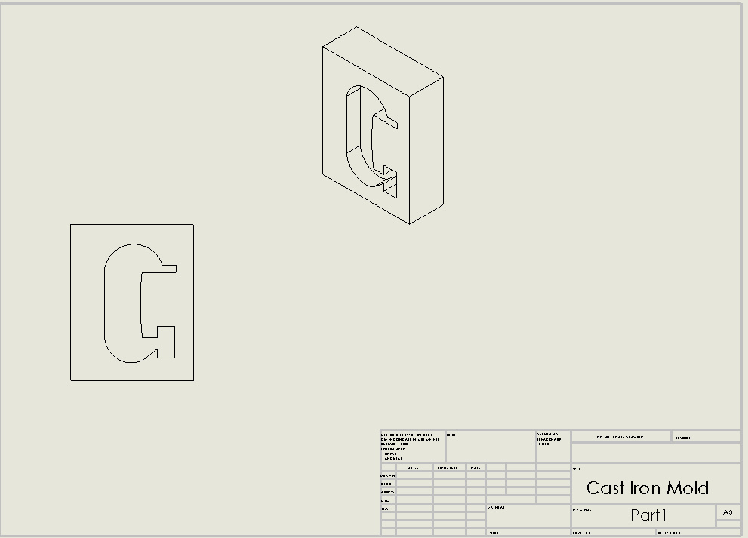
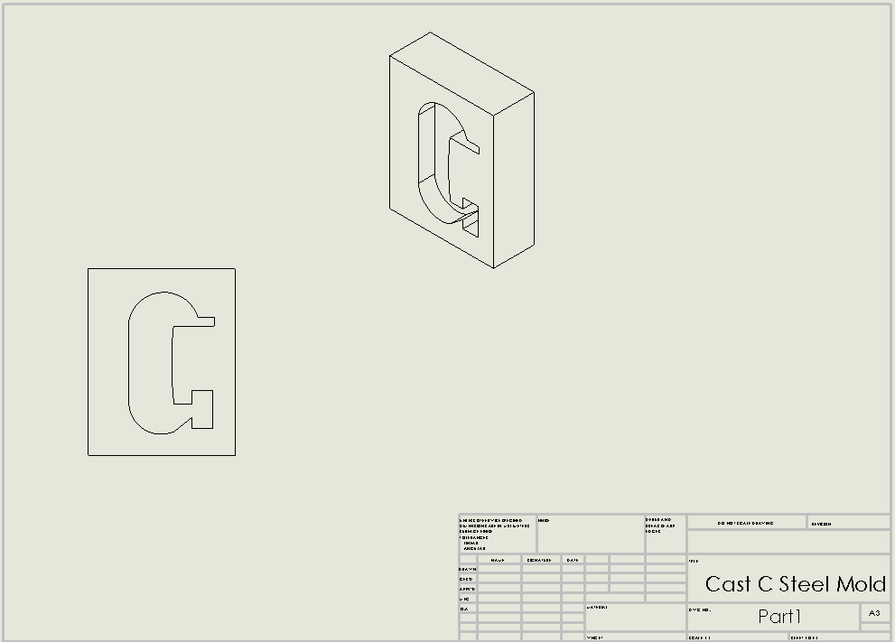

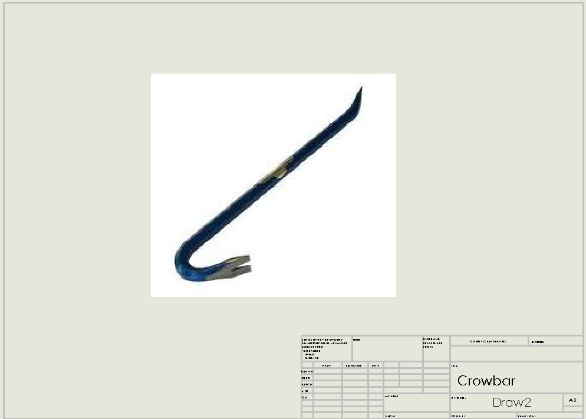
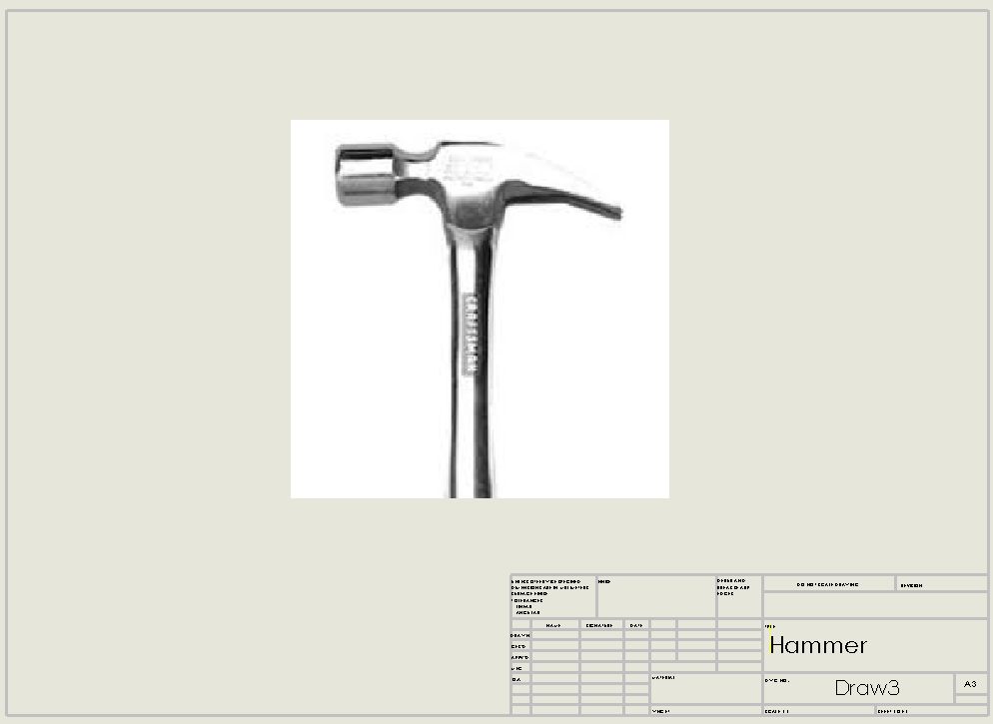
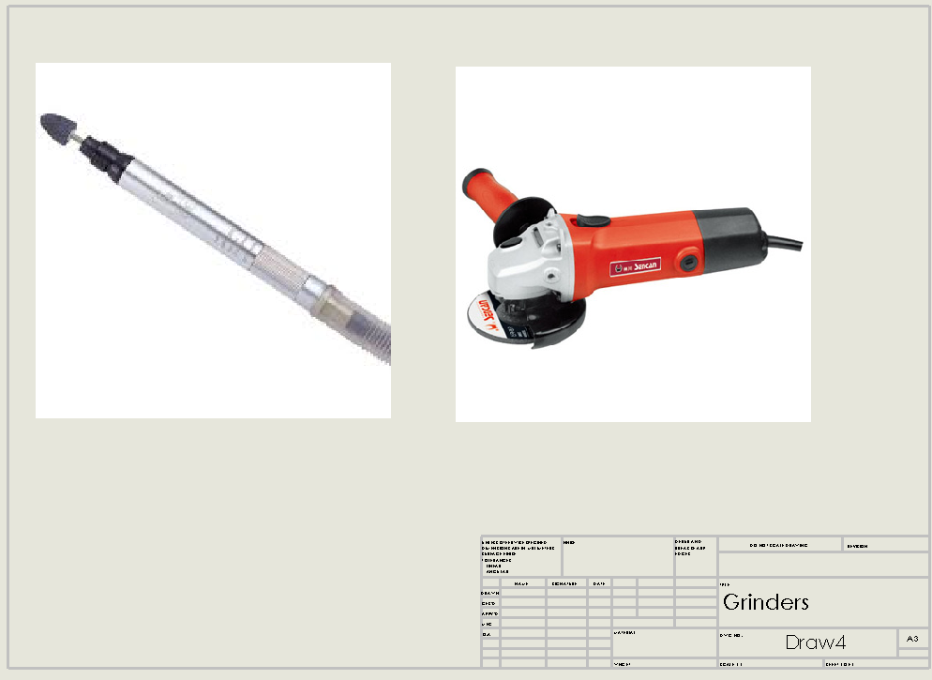

Phase III: Layout Planning and Material Handeling

Layout Planning Sheets

 |  |  | C-Clamp

MATERIAL HANDLING REQUIREMENTS AND COSTS TABLE
EQUIPMENT TYPE | DESCRIPTION | DISTANCE (ft) |  | CAPACITY | NO REQ’D | COST/UNIT | TOTAL COST
Forklift | YALE ELECTRIC FORKLIFT LIFT TRUCK ERC060 | 40 |  | 4600 LBS  22’ Lift | 4 | $4695.99 | $18783.96
Conveyor | Ashland Conveyor W10F10KG45B10 Roller Conveyor | 4 |  | Overall Length 10 Ft  Roller Capacity 270 Lb  Overall Width 12 3/4 In | 4 | $350 | $1400
TOTAL |  |  |  |  |  |  | $20183.96
ANNUAL COST

Phase IV: Personnel Requirements

Personnel requirements and costs
- Direct factory personnel and costs.
  - Machine Operators
    - 1 man per machine x 4 machines x $8.00 per hour x 8 hours per day = $256.00 per day
  - Assembly Workers
    - 1 man per machine x 4 machines x $8.00 per hour x 8 hours per day = $256.00 per day
- Indirect factory personnel and costs.
  - Production Supervisor
    - 1 man per factory x 1 factory x $14.00 per hour x 8 hours per day = $112.00 per day
  - Maintenance Supervisor
    - 1 man per 8 machines x 8 machines x $14.00 per hour x 8 hours per day = $112.00 per day
  - Ship/Receiving Supervisor
    - 1 man per factory x 1 factory x $12.00 per hour x 8 hours per day = $96.00 per day
  - Maintenance
    - 1 man per 8 machines x 8 machines x $10.00 per hour x 8 hours per day = $80.00 per day
  - Forklift Operators
    - 1 man per 4 machines x 8 machines x $8.00 per hour x 8 hours per day = $128.00 per day
  - Janitor, Inspectors
    - 1 man per 4 machines x 8 machines x $8.00 per hour x 8 hours per day = $128.00 per day
- Indirect management personnel and cost.
  - President
    - 1 man per company x I company x $50.00 per hour x 8 hours per day = $400.00 per day
  - Plant Manager
    - 1 man per factory x I factory x $28.00 per hour x 8 hours per day = $224.00 per day
  - Personnel Manager
    - 1 man per factory x 1 factory x $18.00 per hour x 8 hours per day = $144.00 per day
  - Plant Engineer
    - 1 man per factory x 1 factory x $20.00 per hour x 8 hours per day = $160.00 per day
  - IE, ME, Accountant
    - 3 men per factory x 1 factory x $24.00 per hour x 8 hours per day = $576.00 per day
  - Secretaries
    - 1 man per factory x 1 factory x $12.00 per hour x 8 hours per day = $96.00 per day

Corporate structure
- Introductory paragraphs.
This corporate structure is a Bureaucratic Hierarchy that defines power and responsibility within the company. This set-up is very standard in many medium to large scale corporations. At the top is the President who takes the ultimate fall if the corporation fails and reaps the utmost benefits for if it does well. He is in contact with the three main heads of the workforce; Plant Manager, Personnel Manager, and Plant Engineer. Those three head each of their teams. If their team makes a mistake, it is ultimately their fault. Below each of these guys are the individual members of their team which each have a very unique responsibility. The supervisors, who report to the personnel manager, keep the workers in check, and the plant engineer keeps the other engineers in check. The plant manager deals with the accountants and secretaries.
- Diagram showing the structure with well-identified positions and reporting relationships.
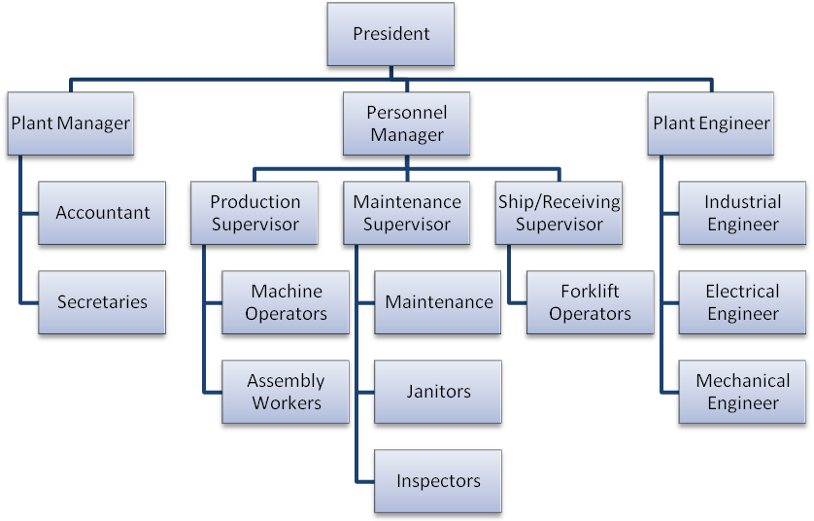

Unit cost
- Calculations
Labor cost per unit = 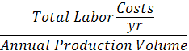
Annual Production Volume = (100 pieces x 4 molds) x 253* working days = 101200
*- 253 working days in 2010
Total Labor Costs = 96+576+160+144+224+400+128+128+80+96+112+112+256+256 = $700304
Labor Cost per unit = 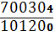 = 6.92

- Discussion of results.
The calculation shows the price that would be ideal for the company in order to break even, meaning there is no loss or gain. This price is just a starting point for the company to begin from and vary the price according to how much profit they are seeking to gain. This number comes from the total labor costs per year divided by the annual production volume. The total labor cost is calculated by adding up

Phase V: Office Layout

Activity relationship chart
- Introductory paragraphs.
The following relationship chart shows how all of the activities are related to each other and there level of importance. There are several levels so that the range is broad enough to make sure that a difference is shown. Below the relationship chart is a diagram showing how the department would need to be arranged in order optimize space effectively. This setup allows for the product to flow from one station to the next with traversing the entire factory.
- Charts with closeness codes.
A: Absolutely necessary
E: Especially important
I: Important
O: Ordinary closeness
U: Unimportant
X: Undesirable

- FLAP, GMAFLAD, or STEP runs. 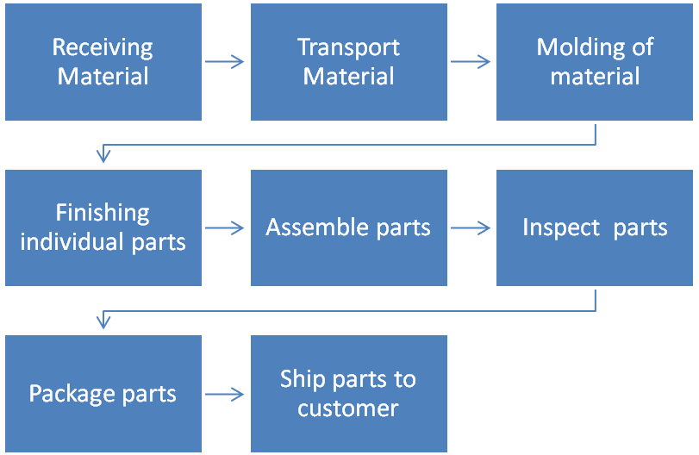

Alternative office layouts

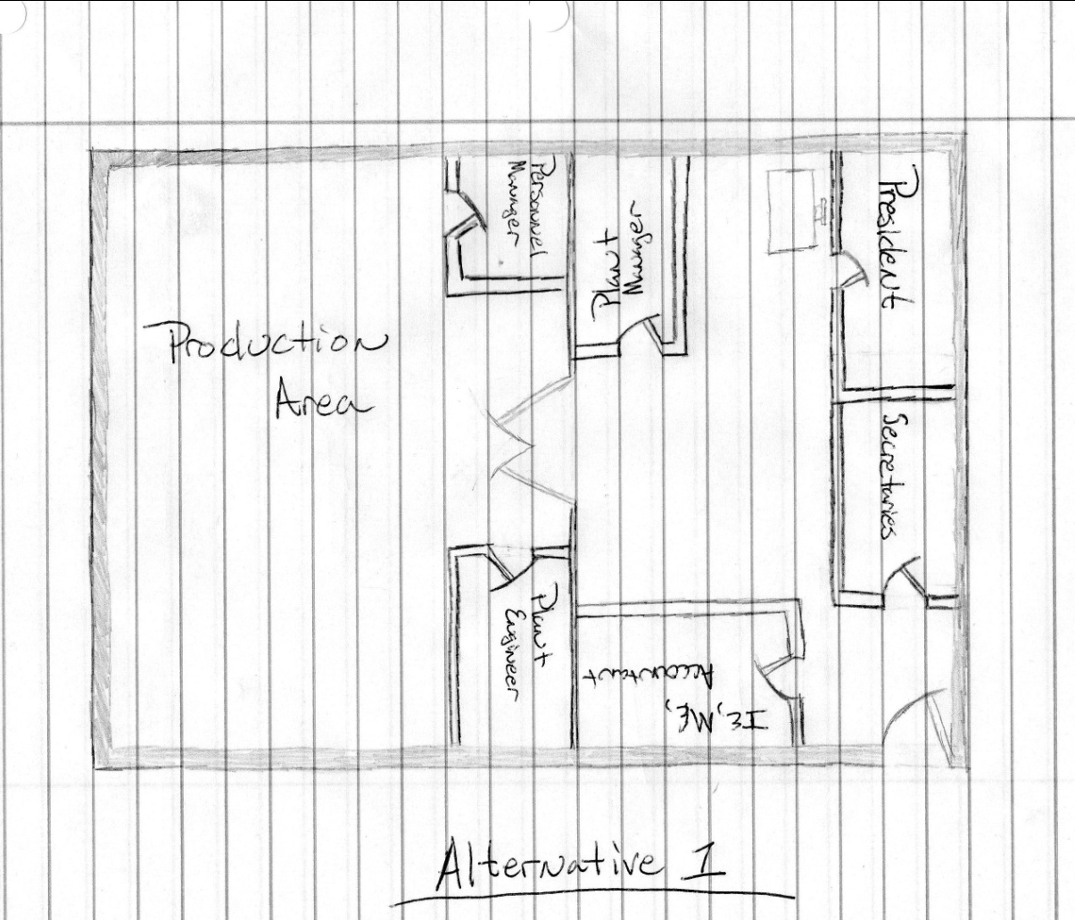
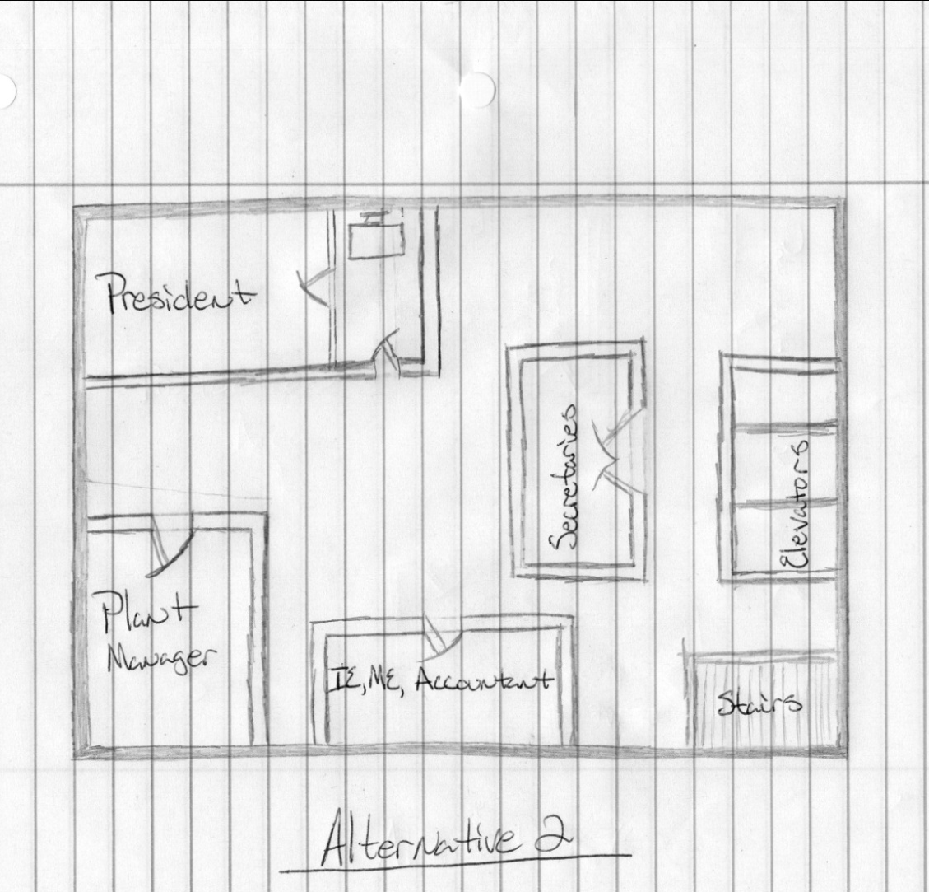

Selected office layout
- Minimal requirements are: president office, secretary office, and accounting office.
- Alternate 2 was selected, because there is more efficient use of office space. If there were only one floor the floor layout would be more compact. Also using a two-floor plan it allows the production area to be more spacious and efficient.

Phase VI: Factory Layout

Introduction
Relevant background
We are a small company and the idea is for us to have a small factory to make our brand of c-clamps. We only plan to hire about 22 workers and build a factory of about 1000 sq ft. We only need room for 4 cast molding machines and 4 assembly lines and the rest of the area is for shipping and management. This will be a small operation that could grow depending on the success of our product so we do need room for some expansion.
Scope of Report
This report is to include all the relevant details for the plant layout best suited for our operation. We have included all the design phases up to this point and all the data, tables, and figures acquired during this project. We have omitted many possible unknown variables in our figures as they are nearly impossible to predict. We are also basing our finding on assumptions made by the team on the time each piece takes to be created as well as the number of men required to run a machine.
Organization of report
This report is split up into 6 sections, each section detailing all the required information for each phase of the project. Included in the sixth section is a summary of all the enhancements we have made to the designs of the production line and facility layouts, Computerized Approach for how the facility layout should be modified to be more efficient, the plant layout summary sheet detailing all the major information pertaining to the facility layout, and our final summary, conclusions, and recommendations for this plant layout and this project

Summary of Enhancements
As we worked on each phase of this project, we made sure each section was as optimal as possible. We made sure to use the least amount of energy required to make the product including using fewer materials, machinery, and workers. This allowed our facility layout to be very optimal, needing only small enhancements to accommodate the machinery and workers for this plant. Our layout was enhanced by simply re-arranging the location according to the data obtained in other sections, to create a highly optimal layout for the offices and work floor.

Computerized Approach
Initial Layout
- The initial layout proposed was to have a one-story building that would take up a lot of area, and required a lot of land. The one story building would have small offices and even some open desks.

Proposed Modifications
- The propose that the building is made to be two-stories , to be more spacious and allow more room for the production area.
Computer Input
- Not applicable, no FLAP program
Computer Output
- Not applicable, no FLAP program

Proposed Layout
Plant and Office
- 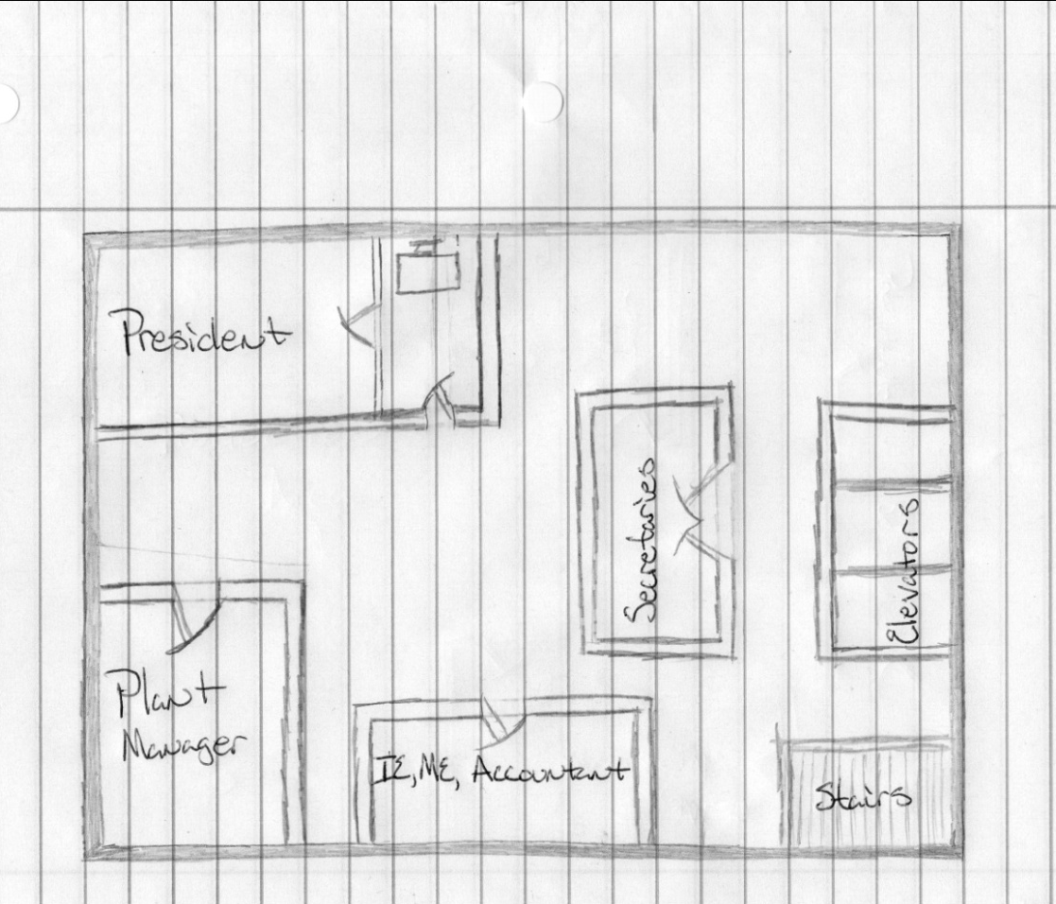
- Top floor shown
- The main floor will just be a production area equipped with break room.
- 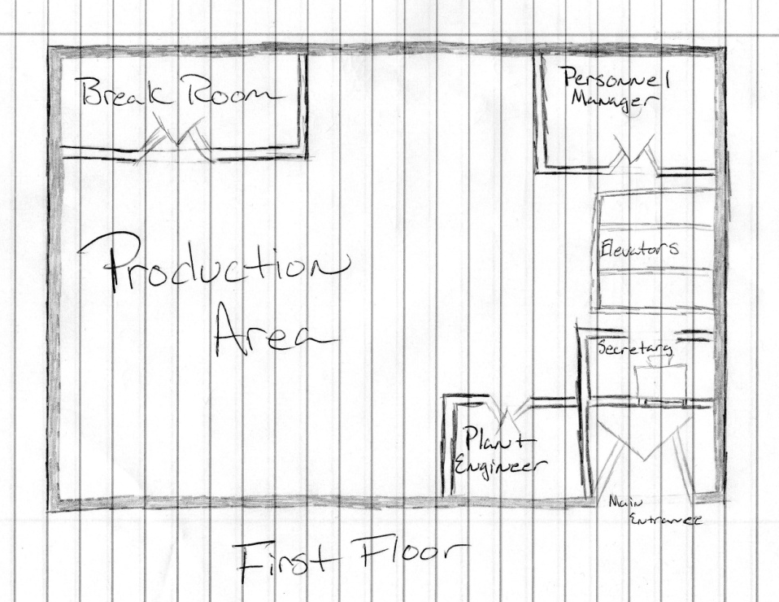
Material Flows for Selected Parts

Plant Layout Summary Sheet
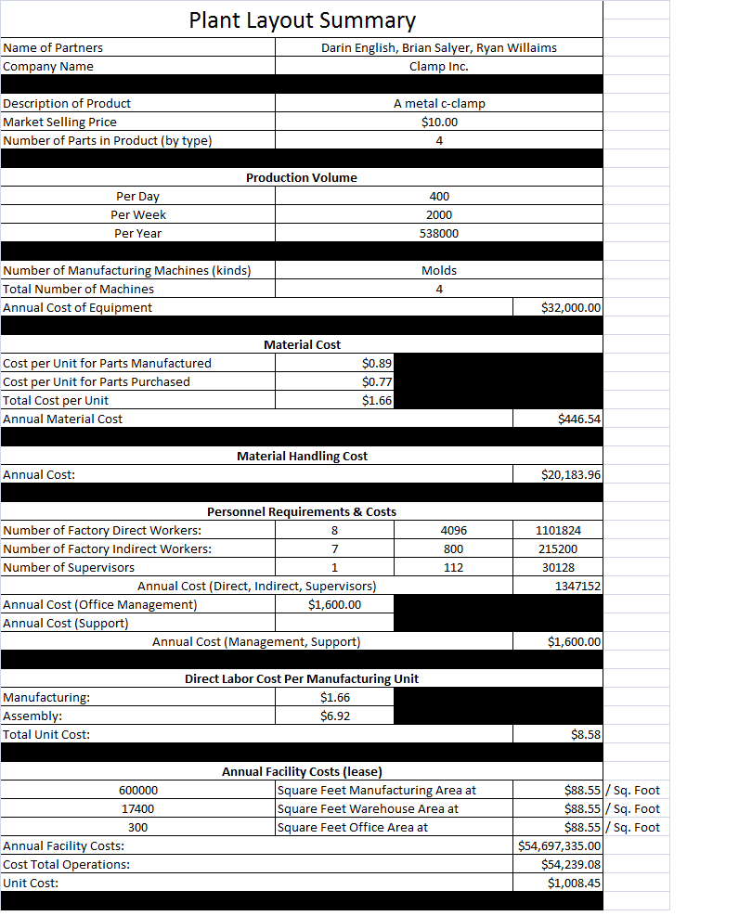

Summary, Conclusions, and Recommendations

Our facility is equipped with enough area to mass produce the c-clamps, and spacious enough to have comfortable office areas for our executives. The first floor will now be equipped with a break room for employee leisure time. We have incorporated the needs of our product and executives into our facility, and we believe that it will compensate us greatly.

